Create virtual hosts mapped to the domain names webtech1.secure.org

1. Update repositories before any installation or configuration

sudo apt-get update

1. Install apache

* If apache is already installed proceed to next step

sudo apt-get install apache2

1. Next is to create a directory

sudo mkdir –p /var/www/webtech1.secure.org/public_html

1. Grant permissions

sudo chown –R $USER:$USER /var/www/webtech1.secure.org/public_html

1. Set permissions at the main root www folder

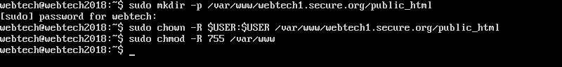Sudo chmod –R 755 /var/www/

1. Go to the folder to create a dummy page

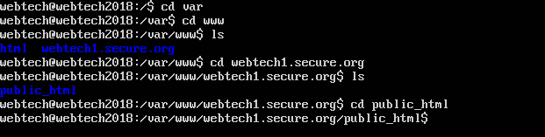cd /etc/www/webtech1.secure.org/public_html

1. Create a dummy page in the folder

* You can use nano or vi in editing

Nano /var/www/webtech1.secure.org/public_html/index.html

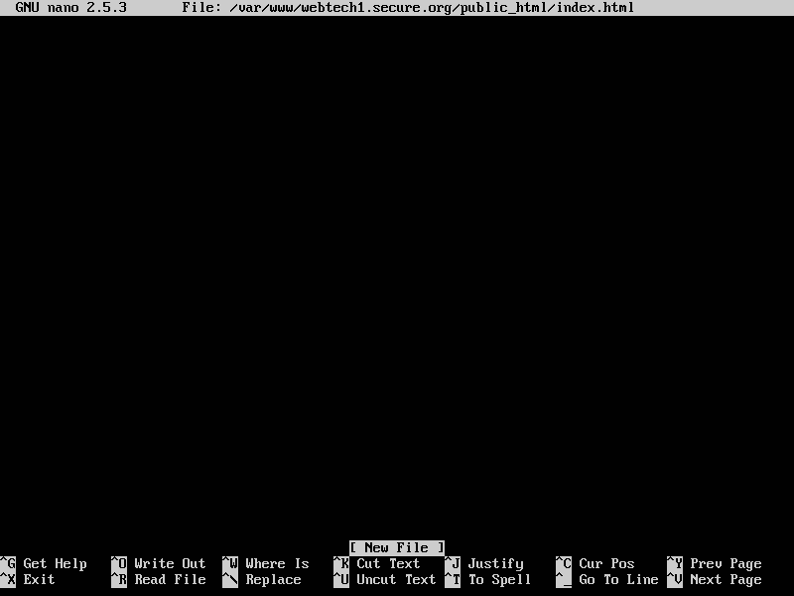 …Press enter

1. Start coding

After coding to save just press ctrl + x

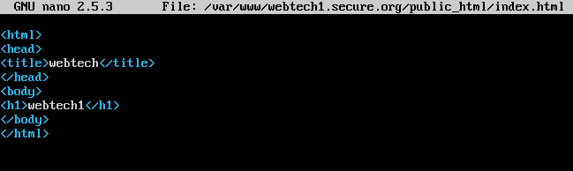 And type Y then to confirm changes and enter

1. Create a new virtual host

* Remember that they already provide a virtual host file the: 000-default.conf
* We need to create a new virtual host but to copy the information within the 000-default.conf into the new virtual host.

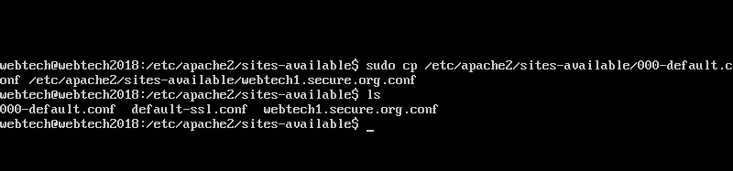sudo cp /etc/apache2/sites-avaible/000-default.conf /etc/apache2/sites-available/webtech1.secure.org.conf

* The webtech1.secure.org.conf is been created

1. Open the file webtech1.secure.org.conf

sudo nano /etc/www/apache2/sites-available/webtec1.secure.org.conf

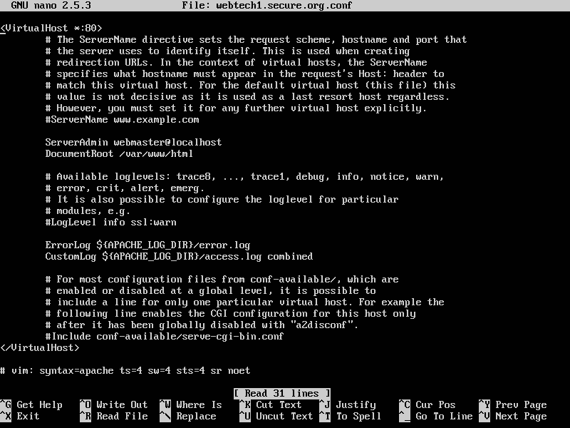

1. You can delete all the comments and this will be it looks like

<VirtualHost *:80>

ServerAdmin webmaster@localhost

DocumentRoot /var/www/html

ErrorLog ${APACHE_LOG_DIR}/error.log

CutomLog ${APACHE_LOG_DIR}/access.log combined

<</VirtualHost>

# vim: syntax=apache ts=4 sw=4 sts=4 sr noet

* **And add and change the following**

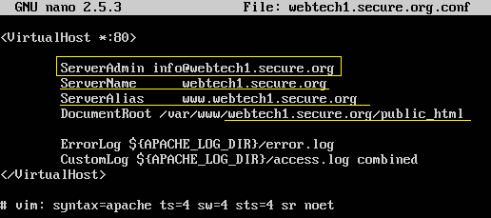

**And Save it.**



* Next is to enable the virtual host

**sudo a2ensite webtech1.secure.org.conf**

* Disable the default on because apache give the 000-deafault.conf

**sudo a2dissite 000-deafault.conf**

* And Restart the Apache Server

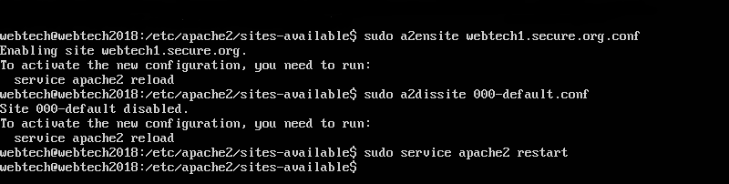**sudo service apache2 restart**

1. Set up a host file

**sudo nano /etc/host**

**add your Ip address and your domain name**

** 192.168.254.27 webtech1.secure.org**

**And go to the Web Borwser**



**Create a SSL Certificate**

1. Activate the SSL module

**sudo a2enmod ssl**

And you have to restart the webserver to recognize the change

**sudo service apache2 restart**

1. Create a Self-Signed SSL Certificate

* Create a subdirectory within apache configuration hierarchy

**sudo mkdir /etc/apache2/ssl**

* Now we have created a location to create the key and certificate
* We can now create them both in one step

**sudo openssl req -x509 -nodes -days 365 -newkey rsa:2048 -keyout /etc/apache2/ssl/apache.key -out /etc/apache2/ssl/apache.crt**

* Upon heating the enter key
* Question will be ask like:

**Country Name (2 letter code) [AU]:**

**State or Province Name (full name) [Some-State]:**

**Locality Name (eg, city) []:**

**Organization Name (eg, company) [Internet Widgits Pty Ltd]:**

**Organizational Unit Name (eg, section) []:**

**Common Name (e.g. server FQDN or YOUR name) []:**

**Email Address []:**

* Answer the following question
* Based it into the picture

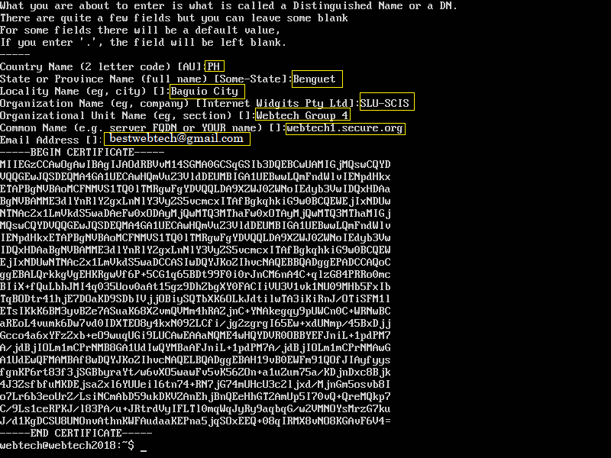

In the /etc/apache2/ssl directory it is where the key and certificate will be created.

1. Configure apache to use SSL

* Open the file with root privileges now

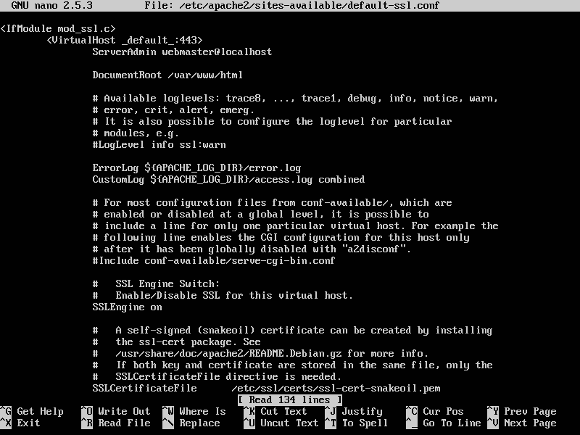**sudo nano /etc/apache2/sites-available/default-ssl.conf**

* You can delete all the comments
* 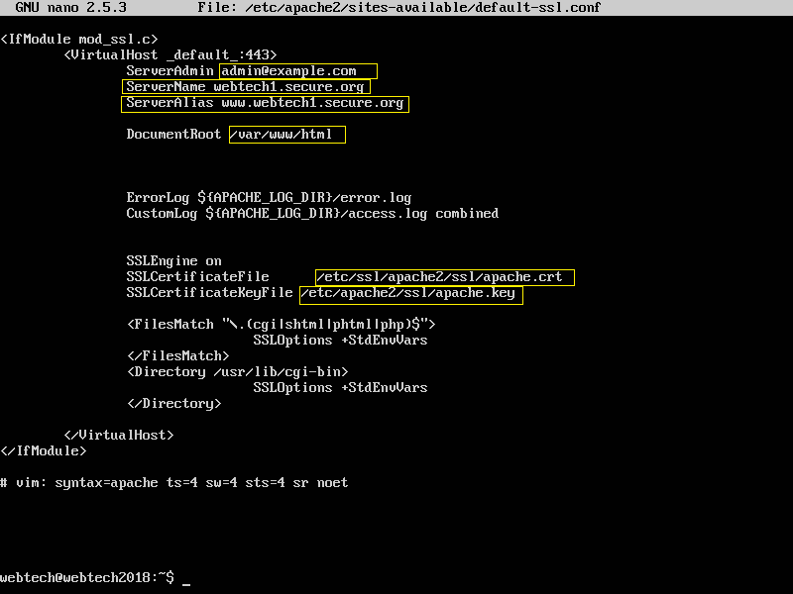Base in the picture below to Change and add detail

**And save it**

1. Now let’s enable/activate the SSL Virtual Host

**sudo a2ensite default-ssl.conf**

* And restart apache

**Now you can test your website**

**https://server_domain_name_or_IP**